UEEN2013/UEEN2342 TCP/IP Network Fundamentals

Lab 03: Basic Routing

Instructions:
- Perform all the lab exercises, starting with exercise 1
- Try to understand the exercises and the commands, and don’t just type the commands “blindly” without much studies and understanding.

Exercise 1: Static Route Configuration

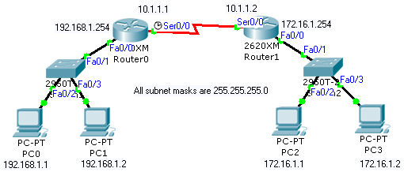
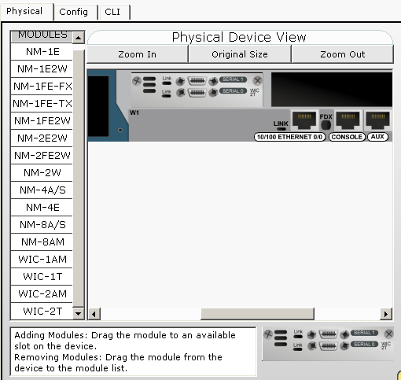 | Choose WIC-2T as your extra module for the serial communication for both routers. Put the module in the left WIC slot.

- Build the above network with two 2620XM routers. In this exercise, we will learn how to use and configure a serial connection. Add in an extra WIC-2T as shown in the above figure.


- Connect the two routers with serial DCE wire (Choose the cable with the above icon). Remember to connect to serial0/0 of both routers.

- Configure the IP addresses and gateway addresses for all PCs.

- For Router0, refer to the following commands for IP address and static routing.
Router(config)#hostname Router0
Router0(config)#interface serial0/0
Router0(config-if)#ip address 10.1.1.1 255.255.255.0
Router0(config-if)#clock rate 128000
Router0(config-if)#no shutdown
Router0(config-if)#exit
Router0(config)#ip route 172.16.1.0 255.255.255.0 10.1.1.2

- For Router1, configure the IP address and static routing.
Router(config)#hostname Router1
Router1(config)#interface serial0/0
Router1(config-if)#ip address 10.1.1.2 255.255.255.0
Router1(config-if)#clock rate 128000 (already in Router0)
Router1(config-if)#no shutdown
Router1(config-if)#exit
Router1(config)#ip route 192.168.1.0 255.255.255.0 10.1.1.1

- If you set the static routes and configure the IP addresses correctly, PC0 should be able to ping PC2 and PC3.

- For serial connection, you need to set clock rate since it is synchronous connection. Otherwise the serial connection won’t work properly. The unit of 128000 is bits per second. You can set the clock rate of the serial line up to 4000000, but just remember to set the same clock rate at both serial ports.

Exercise 2: Static Routing for Routers Connected a Switch

- Build the following network with the IP addresses and gateway addresses stated in the figure. All subnet masks are 255.255.255.0. Keep it as a good habit to change the hostname of the router in CLI to match the name in the figure.
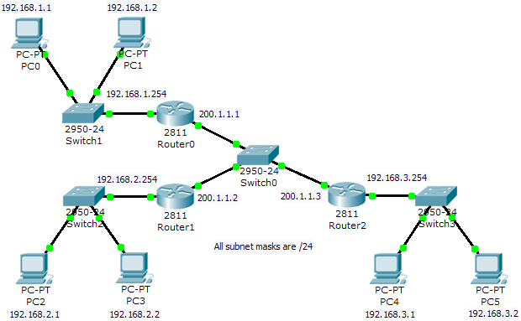

- Set the static routes by referring to the following commands. Each router requires two static routes to point to other subnets.

For Router0
===========
Router0(config)#ip route 192.168.2.0 255.255.255.0 200.1.1.2
Router0(config)#ip route 192.168.3.0 255.255.255.0 200.1.1.3

For Router1
===========
Router1(config)#ip route 192.168.1.0 255.255.255.0 200.1.1.1
Router1(config)#ip route 192.168.3.0 255.255.255.0 200.1.1.3

For Router2
===========
Router2(config)#ip route 192.168.2.0 255.255.255.0 200.1.1.2
Router2(config)#ip route 192.168.1.0 255.255.255.0 200.1.1.1

- Use PC0 to ping other PCs in order to test the connectivity of all the subnets.

- Check the routing tables of each routers by typing:
Router0#show ip route
Router1#show ip route
Router2#show ip route

Exercise 3: Default Route

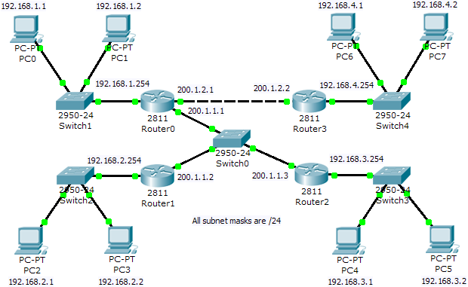

- Based on the network in exercise 2, extend the network that includes subnet 192.168.4.0 as shown in figure. Backup the running-config file of Router0 to startup-config (“copy run start”), while you add in an extra module NM-2FE2W to Router0, because you need to on and off Router0.

- Add in the static routes by referring to the following commands (assume that you have done exercise 2 correctly). Please study and understand the commands on why the static routes have to set in such as way.

For Router0
===========
Router0(config)#ip route 192.168.4.0 255.255.255.0 200.1.2.2

For Router1
===========
Router1(config)#ip route 192.168.4.0 255.255.255.0 200.1.1.1

For Router2
===========
Router2(config)#ip route 192.168.4.0 255.255.255.0 200.1.1.1

For Router3
===========
Router3(config)#ip route 0.0.0.0 0.0.0.0 200.1.2.1

- Use PC0 to ping other PCs in order to test the connectivity of all the subnets.

- Check the routing tables of each routers by typing:
Router0#show ip route
Router1#show ip route
Router2#show ip route
Router3#show ip route

- Note: If you don’t use the default route in Router3 (ip route 0.0.0.0 0.0.0.0 next_hop_IP). You have to type the static route commands as shown in the following. In a way, default route save you from typing some “extra” commands. (You do NOT need to type the following commands in Router3.)
Router3(config)#ip route 192.168.1.0 255.255.255.0 200.1.2.1
Router3(config)#ip route 192.168.2.0 255.255.255.0 200.1.2.1
Router3(config)#ip route 192.168.3.0 255.255.255.0 200.1.2.1

Note on default route

ip route 0.0.0.0 0.0.0.0 next_hop_IP
A default route, also known as the gateway of last resort, is the network route used by a router when no other known route exists for a given IP packet's destination address. All the packets for destinations not known by the router's routing table are sent to the default route. This route generally leads to another router, which treats the packet the same way: If the route is known, the packet will get forwarded to the known route. If not, the packet is forwarded to the default-route of that router which generally leads to another router.

Exercise 4: Dynamic Routing - RIP

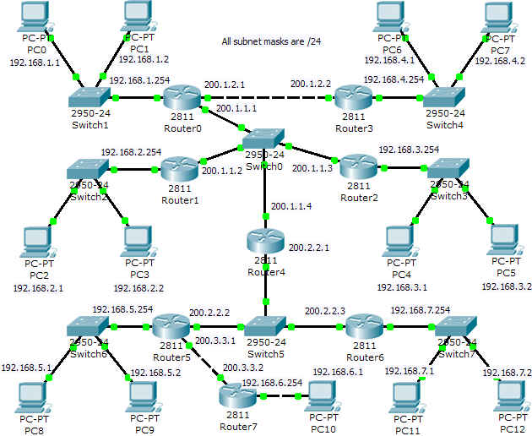

- Extend the network in Exercise 3 to include Router3, Router4, Router5, Router6, and Router7 with the switches and the PCs. Please configure the IP addresses and the gateway IP addresses according to the labels in the figure. Make sure that you have NOT set any static routes in network.

- Set the dynamic routes by referring to the following commands. Dynamic routes are configured by software, in this case RIP (routing information protocol). Please study them carefully. Basically, each router has to “advertise” the subnets attached to it with the command “network a.b.c.d”, after the command “router rip”.

For Router0
===========
Router0(config)#router rip
Router0(config-router)#network 200.1.1.0
Router0(config-router)#network 192.168.1.0
Router0(config-router)#network 200.1.2.0
Router0(config-router)#exit

For Router1
===========
Router1(config)#router rip
Router1(config-router)#network 200.1.1.0
Router1(config-router)#network 192.168.2.0
Router1(config-router)#exit

For Router2
===========
Router2(config)#router rip
Router2(config-router)#network 200.1.1.0
Router2(config-router)#network 192.168.3.0
Router2(config-router)#exit

For Router3
===========
Router3(config)#router rip
Router3(config-router)#network 192.168.4.0
Router3(config-router)#network 200.1.2.0
Router3(config-router)#exit

For Router4
===========
Router4(config)#router rip
Router4(config-router)#network 200.1.1.0
Router4(config-router)#network 200.2.2.0
Router4(config-router)#exit

For Router5
===========
Router5(config)#router rip
Router5(config-router)#network 200.2.2.0
Router5(config-router)#network 192.168.5.0
Router5(config-router)#network 200.3.3.0
Router5(config-router)#exit

For Router6
===========
Router6(config)#router rip
Router6(config-router)#network 200.2.2.0
Router6(config-router)#network 192.168.7.0
Router6(config-router)#exit

For Router7
===========
Router7(config)#router rip
Router7(config-router)#network 200.3.3.0
Router7(config-router)#network 192.168.6.0
Router7(config-router)#exit

- After you have key in all the commands, please wait for a while (around 3 minutes) for the RIP software to configure the dynamic routes in all the routers.

- Use one PC of each subnet to ping other PCs in order to test the connectivity of all the subnets. Troubleshoot the network if necessary.

- Check the routing tables of each router.
Router0#show ip route
Router1#show ip route
Router2#show ip route
Router3#show ip route
Router4#show ip route
Router5#show ip route
Router6#show ip route
Router7#show ip route

Exercise 5: Dynamic Routing - OSPF

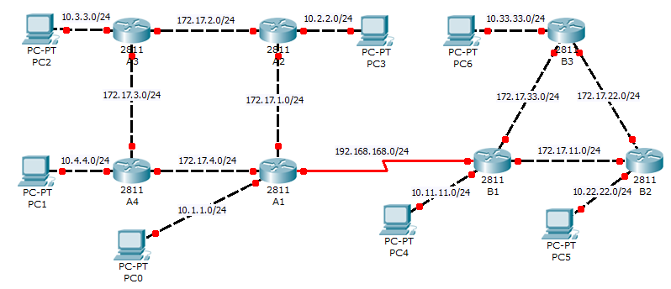

- Set up the network above. Configure all router interfaces and PCs with the appropriate IP addresses based on the network addresses shown.

- Configure single area OSPF on all routers (Area 0).

Router A1
A1(config)#router ospf 1
A1(config-router)#network 10.1.1.0 0.0.0.255 area 0
A1(config-router)#network 172.17.1.0 0.0.0.255 area 0
A1(config-router)#network 172.17.4.0 0.0.0.255 area 0
A1(config-router)#network 192.168.168.0 0.0.0.255 area 0

Router A2
A2(config)#router ospf 1
A2(config-router)#network 10.2.2.0 0.0.0.255 area 0
A2(config-router)#network 172.17.1.0 0.0.0.255 area 0
A2(config-router)#network 172.17.2.0 0.0.0.255 area 0

Router A3
A3(config)#router ospf 1
A3(config-router)#network 10.3.3.0 0.0.0.255 area 0
A3(config-router)#network 172.17.2.0 0.0.0.255 area 0
A3(config-router)#network 172.17.3.0 0.0.0.255 area 0

Router A4
A4(config)#router ospf 1
A4(config-router)#network 10.4.4.0 0.0.0.255 area 0
A4(config-router)#network 172.17.3.0 0.0.0.255 area 0
A4(config-router)#network 172.17.4.0 0.0.0.255 area 0

Router B1
B1(config)#router ospf 1
B1(config-router)#network 10.11.11.0 0.0.0.255 area 0
B1(config-router)#network 172.17.11.0 0.0.0.255 area 0
B1(config-router)#network 172.17.33.0 0.0.0.255 area 0
B1(config-router)#network 192.168.168.0 0.0.0.255 area 0

Router B2
B2(config)#router ospf 1
B2(config-router)#network 10.22.22.0 0.0.0.255 area 0
B2(config-router)#network 172.17.11.0 0.0.0.255 area 0
B2(config-router)#network 172.17.22.0 0.0.0.255 area 0

Router B3
B3(config)#router ospf 1
B3(config-router)#network 10.33.33.0 0.0.0.255 area 0
B3(config-router)#network 172.17.22.0 0.0.0.255 area 0
B3(config-router)#network 172.17.33.0 0.0.0.255 area 0

- Ensure that all PCs can ping each other.

- Experiment with OSPF cost settings on the router interfaces to affect the best route calculation. Try to configure OSPF cost on the required router interfaces so that packets from PC1 to PC4 will travel through Routers A4, A3, A2, A1 and finally B1.

- Switch to Simulation mode.
- Drag a Simple PDU and click on PC1 and PC4. Click on Auto Capture/Play button. Observe the path travelled by the packet from PC1 to PC4.
- Switch back to Realtime mode.
- Perform the configuration on A4.
A4(config)#interface fa0/1
A4(config-router)#ip ospf cost 1000
- Repeat Step (a) and (b).

